Mesh cloth | DONGGUAN LU YU SHOES MATERIAL CO..LTD | LY-1366(100%Recycled polyester) | Complied with Glow-Wire test at 550 °C | IEC/EN 62368-1 | Tested with appliance
实物图片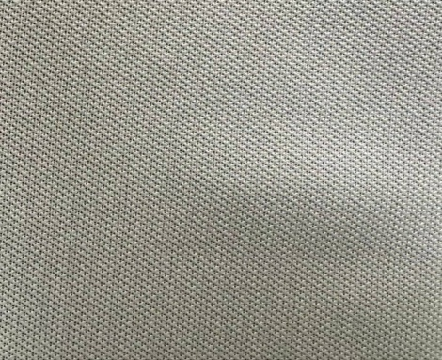
Mesh cloth | DONGGUAN LU YU SHOES MATERIAL CO..LTD | LY-24234(100%Recycled polyester) | Complied with Glow-Wire test at 550 °C | IEC/EN 62368-1 | Tested with appliance
实物图片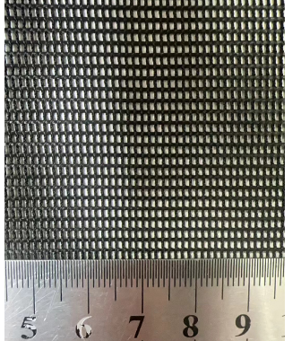
Mesh cloth | DONGGUAN LU YU SHOES MATERIAL CO..LTD | LY-24234-1(100%Recycled polyester) | Complied with Glow-Wire test at 550 °C | IEC/EN 62368-1 | Tested with appliance
实物图片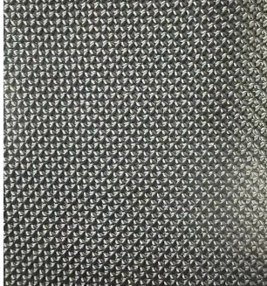
Mesh cloth | DONGGUAN LU YU SHOES MATERIAL CO..LTD | LY-W3117(100%Recycled polyester) | Complied with Glow-Wire test at 550 °C | IEC/EN 62368-1 | Tested with appliance
实物图片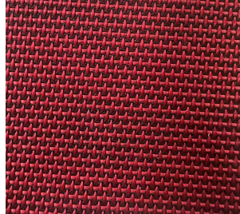
Mesh cloth | DONGGUAN LU YU SHOES MATERIAL CO..LTD | LY-S230518 | Complied with Glow-Wire test at 550 °C | IEC/EN 62368-1 | Tested with appliance
实物图片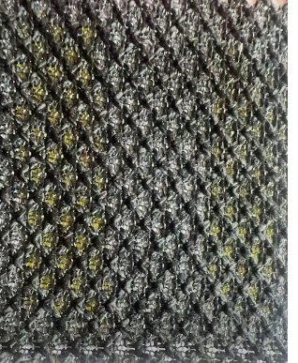
Mesh cloth | DONGGUAN LU YU SHOES MATERIAL CO..LTD | LY-S230522 | Complied with Glow-Wire test at 550 °C | IEC/EN 62368-1 | Tested with appliance
实物图片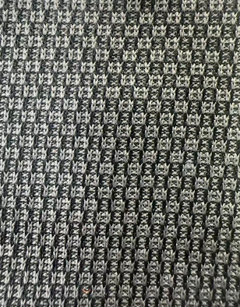
Mesh cloth | DONGGUAN LU YU SHOES MATERIAL CO..LTD | LY-5158 | Complied with Glow-Wire test at 550 °C | IEC/EN 62368-1 | Tested with appliance
实物图片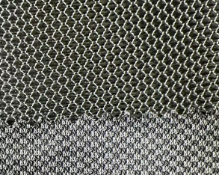
Mesh cloth | DONGGUAN LU YU SHOES MATERIAL CO..LTD | LY-JH5 | Complied with Glow-Wire test at 550 °C | IEC/EN 62368-1 | Tested with appliance
实物图片